**Department of Computer Engineering**

BLG 351E  
Microcomputer Laboratory Experiment Report

Experiment No : 8

Experiment Date : 08.12.2017

Group Number : Friday - 13

Group Members :

|  |  |  |
| --- | --- | --- |
| **ID** | **Name** | **Surname** |
| 150160537 | OKAN | YILDIRIM |
| 150160546 | HASAN EMRE | ARI |
|  |  |  |

Laboratory Assistant : Yusuf Hüseyin Şahin

# Introduction

In this experiment, we implement a program that displays the value on the LCD screen from the thermometer on DS18B20 by using MSP430 Education Board, MSP430G2553 microcontroller and its assembly language. Before the experiment, we studied on Background information and Experiment sheet in detail. We used the information that initialize to LCD from previous experiment. For using the thermometer, we read the datasheet of DS18B20 to ready experiment. In particular, we studied on thermometer initialization, ROM commands, function commands, 1 wire bus protocol and resolution of measure the thermometer.

# Experiment

This experiment was more difficult and different other experiments. Timing and delays are vital for this experiment and it is required to read and understand the datasheet of DS18B20 well. Especially, understanding 1-Wire Communication Protocol is important to complete this experiment. We did our preliminary work, yet we cannot understand the some parts of this document actually and we try to implement as we understood.

Firstly, we implemented variety of delays such as 60 microseconds, 480 microseconds, 800 milliseconds, , 200 milliseconds, 100 milliseconds according to the datasheet of DS18B20. Then, we implement the LCD part of the program in similar way to the Experiment 7. Then we try to implement ***initTemp*** subroutine which is initialization procedure where you will implement the reset and presence pulse operations, ***Write*** subroutine which is used to write either ROM commands (or function commands and ***Read*** subroutine to read a bit from the 1-wire bus. We did something wrong about calling correct delays unfortunately. Therefore, Our program is did not work correctly. However, order of calling commands and functions in main part is correct absolutely. We try to store read data with stack and then display on the LCD.

Our program and detailed description is given below: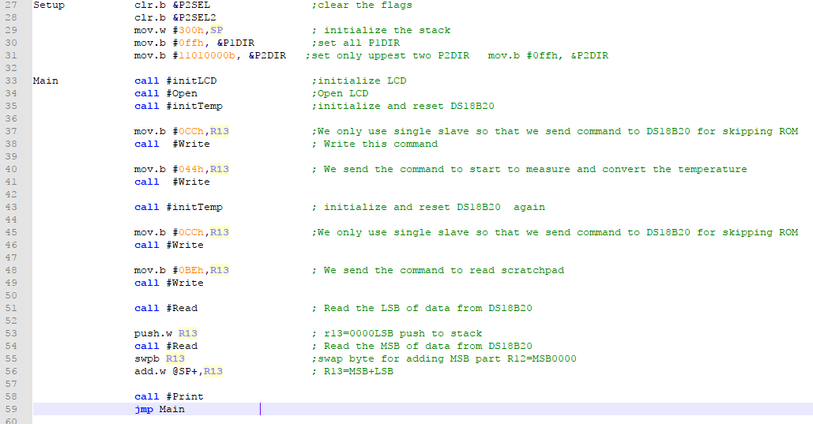

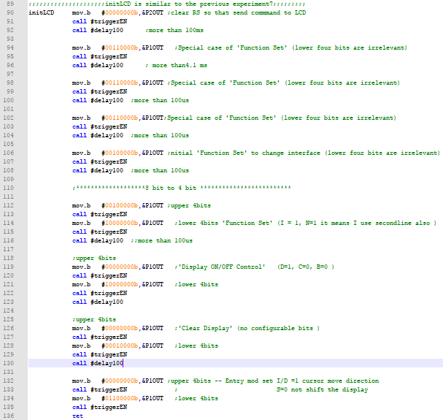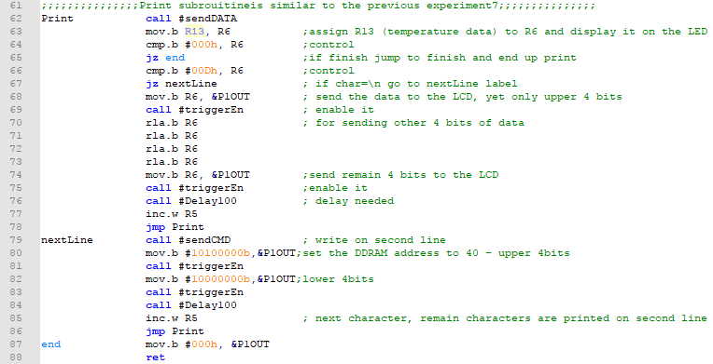

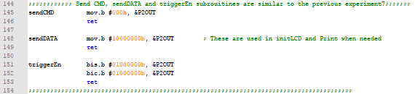

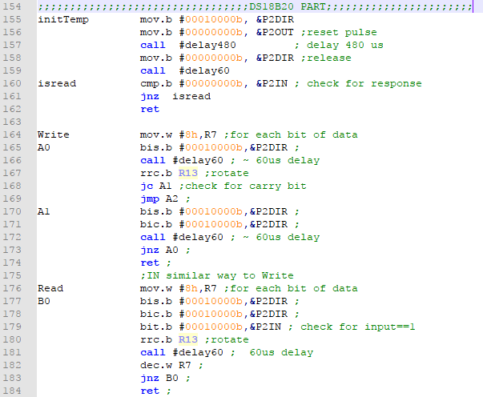

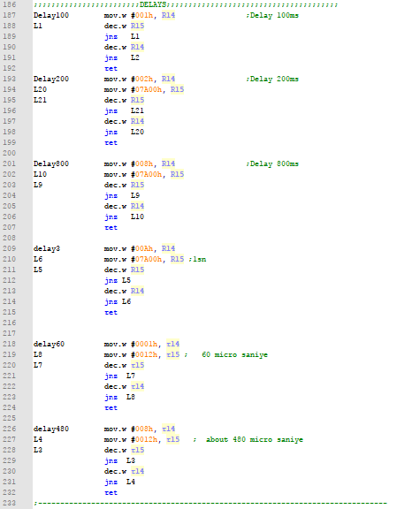

# Conclusion

We could not complete whole experiment. The timing was very important because of the 1 wire bus used in this experiment. We were configure the timing correctly. We had difficulty and make some mistake in this part. Perhaps more specific and descriptive information could be added to the background information from the datasheet of DS18B20. We needed more time for better understood of the documentations before the experiment and also for doing the experiment in class.